**Transition year 6**

*“Transition materials are extremely important and relevant, especially now. They carry the school playground around in their pockets, along with all the good and bad that is inherent there.” -*PSHE teacher, Secondary School, Yorkshire

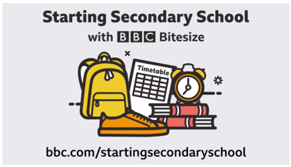

campaign [Starting Secondary School](https://www.bbc.com/bitesize/tags/zh4wy9q/starting-secondary-school/1)

Click on the link which is designed to help support the critical step of beginning Secondary school.