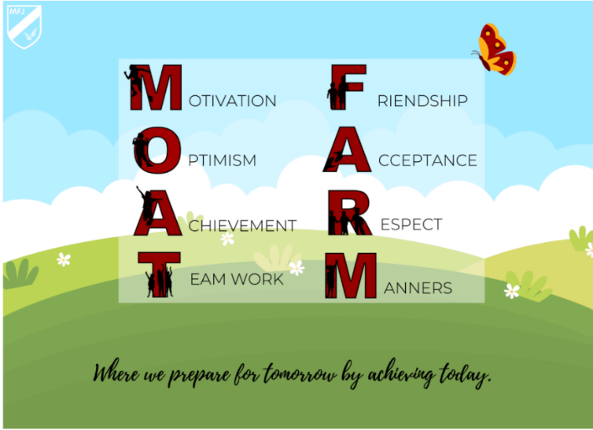

At Moat Farm Junior, we aim to broaden children’s horizons and raise aspirations by nurturing their ambition and confidence to pursue personal goals. We continuously link learning to real life situations and careers, while also instilling a sense of possibility and passion in our children to pursue what they enjoy, regardless of their background, gender or socio-economic status. We work together to increase our children’s confidence through exploring their many interests as well as expanding their knowledge of the world. We encourage fearlessness of what is new, unknown or difficult learning by creating exciting, inspiring opportunities in a fully supportive environment where their efforts play a key part. We recognise the importance of our children being resilient individuals, who are able to take risks and deal with different challenges across the curriculum and in the wider world by thinking positively and having the confidence to ‘have a go’. We work to develop the life skills necessary to work with growing independence and perseverance to become resourceful problem-solvers able to nurture aspirations for the future.

We recognise the importance of our children being resilient individuals, who are able to take risks and deal with different challenges across the curriculum and in the wider world by thinking positively and having the confidence to ‘have a go’. We work to develop the life skills necessary to work with growing independence and perseverance to become resourceful problem-solvers able to nurture aspirations for the future.
A strong aim within our curriculum is for our children to develop the skills necessary to communicate their thoughts, ideas and feelings successfully in a wide range of different forms. Children need to know how to speak and listen with respect in a variety of situations. We nurture our children’s awareness that actions have consequences and to make choices based on awareness, with the understanding that they have ownership of their actions. We believe children should have global awareness and feel responsibility for the part they play in it. At our school, children develop an understanding about where they live and the wider world. Through learning about the world, our children understand their role in society and develop respect towards the environment, communities and have cultural appreciation. At Moat Farm Junior, we want all children to value and respect all members of our community and to be a catalyst for positive change for all. Children are taught the skills for life to enable them to be good citizens and to contribute to the community. Our curriculum excites and motivates children about their learning by linking and embedding, within the curriculum, strong connections between education and their future. We prioritise our children’s ability to read well and read widely as this broadens horizons, develops imagination and provides a rich vocabulary through which to construct knowledge and understand the world.
We believe that our curriculum enables the children to develop the emotional understanding necessary in order to experience positive relationships and to develop a sense of justice and an ability to empathise that ensures a respect of themselves and each other. In our school, we endeavour to continuously develop a love for learning culture, where we will equip all children with the necessary skills in reading, writing and mathematics to succeed. We want children to be confident in asking questions and developing an enquiring mind which will help them reach their potential throughout their life as well as within lessons. We continuously praise the children’s efforts in order for them to love challenges, be intrigued by mistakes, enjoy effort, seek new strategies and keep on learning. Children are engaged by our curriculum that provides opportunities to excite the imagination, advance their knowledge and understanding through a wide range of creative, physical activities that take account of their diverse starting points and nurture their skills and talents, while enriching their experiences of life. Each one of our children’s abilities and needs are catered for in a personalised, individualised manner that supports and challenges them. This provision ensures that each child feels independent and proud of their accomplishments.

